|  |
| --- |
|  |
| ADE SIMULATION |
| 8:1 MULTIPLEXER |

|  |
| --- |
| BY:  SHAIKH FARHAN  USN : 3PD23CS137 |

**8:1 Multiplexer Simulation**

**Theory:-**

The term multiplexer means "many-to-one". A multiplexer (MUX) has an input each line is used to shift digit data serially. There is a single output line one of the data stored in the n input line is transferred to the output based on the value of control bits on n to 1 multiplexer requires 'n' control bits where n<=2m. To construct a 4 variable function we required a 16(2⁴) to 1 multiplexer, where as using an entered variable map method a 4 variable expression can be realized using 8(2³) to 1 multiplexer.

**8:1 MUX PIN Diagram :**

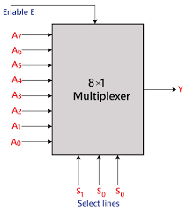

**Circuit Diagram :**

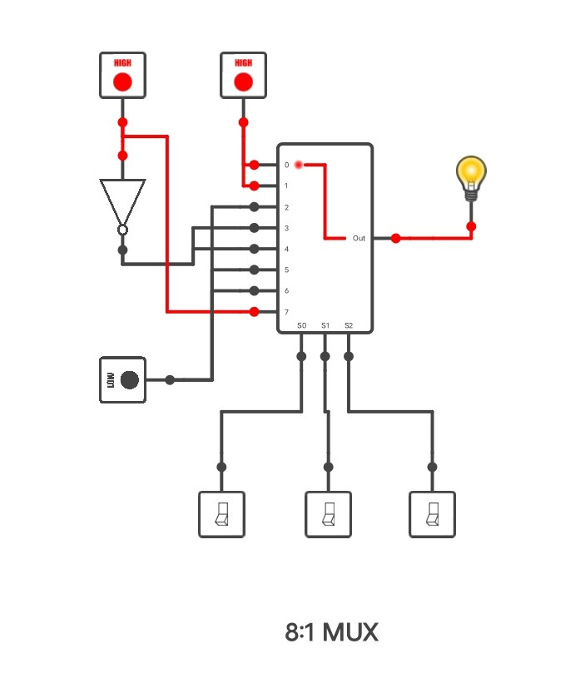

**Truth Table :**

|  |  |  |  |  |  |
| --- | --- | --- | --- | --- | --- |
| minterms | P | Q | R | S | Y |
| 0 | 0 | 0 | 0 | 0 | 1 |
| 1 | 0 | 0 | 1 | 1 | 1 |
| 2 | 0 | 0 | 0 | 0 | 0 |
| 3 | 0 | 0 | 1 | 1 | 1 |
| 4 | 0 | 1 | 0 | 0 | 1 |
| 5 | 0 | 1 | 1 | 1 | 0 |
| 6 | 0 | 1 | 0 | 0 | 0 |
| 7 | 0 | 1 | 1 | 1 | 0 |
| 8 | 1 | 0 | 0 | 0 | 1 |
| 9 | 1 | 0 | 1 | 1 | 1 |
| 10 | 1 | 0 | 0 | 0 | 0 |
| 11 | 1 | 0 | 1 | 1 | 0 |
| 12 | 1 | 1 | 0 | 0 | 0 |
| 13 | 1 | 1 | 1 | 1 | 0 |
| 14 | 1 | 1 | 0 | 0 | 0 |
| 15 | 1 | 1 | 1 | 1 | 1 |

**Thank You .**